PLFA Protocol for nmol calculations from gas chromatograph peaks

Mark De Guzman

October 25, 2017

Notes prior to calculations:

* If you haven’t done already, name the file name so that it will be binned according to batches. e.g. Batch1_001. This will aid in grouping the samples together.

1. Create a pivot table with ‘peak name’ as column label, ‘DataFileName’ as row label, and ‘TotalPeakArea1’ as sum of values. Which creates the table similar to the image below.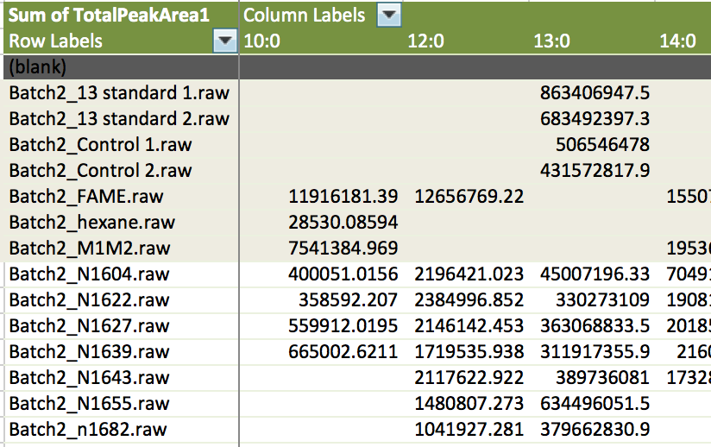
2. Calculate the fractional difference between batches which is done by first calculating the average peak area for each column (fatty acid) per batch, then by dividing the average peak area relative to the highest average peak area. The fractional difference will be used to normalize the peak area values across the runs.

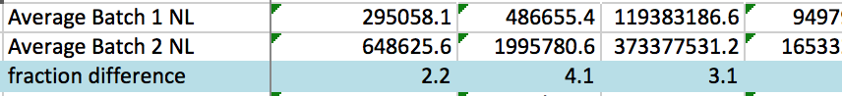

1. Create a new table with the normalized peak area. In the example for the image batch2 values were copied as is, whereas batch1 values were multiplied with the fraction difference correction. Furthermore, the samples will have the average values (average of the blanks) of 13:0 and 19:0 subtracted with the condition that values will be set to zero if the difference is negative (see IF argument in the image).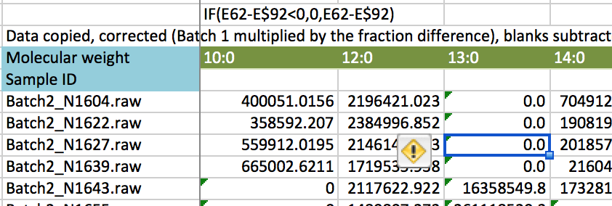
2. K-value (total peak area ng-1) is needed for the next set of calculations. This is computed by dividing the peak area of the 13:0 standard from the batch by 500 ng (500 is used because the protocol uses 250 ng/μL solution and the GC injects 2 μL).

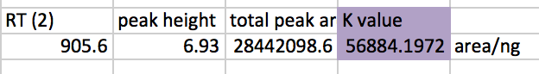

1. The amount of nmol gsoil-1 is calculated by from the equation below:

nmol gsoil-1 = (Peak area/K value)*(total volume in GC vial/2)

(molecular weight of peak * soil mass)

1. Total biomass for each sample ID is calculated from the sum of nmol gsoil-1 values for the peaks indicated below. (Extracted from Gutknecht reference)

|  |  |  |
| --- | --- | --- |
| FAME ID | Molecular weight  (g/mol) | indicates |
| 12:0 | 214 | biomass |
| 13:0 iso | 228 | Gram +bacteria |
| 13:0 anteiso | 228 | Gram +bacteria |
| 13:0 | 228 | biomass |
| 14:0 | 242 | biomass |
| 14:0 3OH | 258 | Gram - |
| 15:0 | 256 | biomass |
| 15:0 iso | 256 | Gram +bacteria |
| 15:0 anteiso | 256 | Gram +bacteria |
| 16:0 | 270 | biomass |
| 16:0 10me | 284 | actinomycetes |
| 16:1 ω5c | 268 | AMF |
| 16:1 ω7c | 268 | Gram -bacteria |
| 16:1 ω9c | 268 | Gram -bacteria |
| 17:0 | 284 | biomass |
| 17:0 anteiso | 284 | Gram +bacteria |
| 17:0 iso | 284 | Gram +bacteria |
| 18:0 | 298 | biomass |
| 18:0 10me | 312 | actinomycetes |
| 18:1 ω7c | 296 | Gram -bacteria |
| 18:1 ω9t | 296 | Gram -bacteria |
| 18:1 ω9c | 296 | S fungi |
| 18:2 ω6,9c | 294 | S fungi |
| 19:0 | 312 | biomass |
| 19:0 cyclo | 310 | anaerobic |

1. Mol% data for each peak for each nmol gsoil-1 value is calculated by dividing each nmol gsoil-1 value by total biomass value (as calculated in step 6) and multiplying by 100.
2. Calculate ratio of fungal lipids to bacterial lipids from values in step 5.

Fungal lipids: 16:1 ωc5,

18:1 ω9c, and 18:2 ω6,9c

Bacterial lipids: 13:0 iso, 13:0 anteiso,

14:0 3OH

15:0 iso, 15:0 anteiso,

16:0 iso, 16:1 ω7c, 16:0 10 me,

17:0 iso, 17:0 anteiso,

18:1 ω9t, 18:1 ω7c, 18:0 10 me